Data Visualization Lab Assignment

## Name: Om Ashish Mishra

## Registration Number: 16BCE0789

## Slot: C2

**Q) Take a text document. Show the word cloud for the document.**

> library("tm")

> library("SnowballC")

> library("wordcloud")

> library("RColorBrewer")

> text <- readLines(file.choose())

Warning message:

In readLines(file.choose()) :

incomplete final line found on 'C:\Users\Aditya Dhall\Desktop\text.txt'

> docs <- Corpus(VectorSource(text))

> inspect(docs)

<<SimpleCorpus>>

Metadata: corpus specific: 1, document level (indexed): 0

Content: documents: 3

[1] Lorem ipsum is a pseudo-Latin text used in web design, typography, layout, and printing in place of English to emphasise design elements over content. It's also called placeholder (or filler) text. It's a convenient tool for mock-ups. It helps to outline the visual elements of a document or presentation, eg typography, font, or layout. Lorem ipsum is mostly a part of a Latin text by the classical author and philosopher Cicero. Its words and letters have been changed by addition or removal, so to deliberately render its content nonsensical; it's not genuine, correct, or comprehensible Latin anymore. While lorem ipsum's still resembles classical Latin, it actually has no meaning whatsoever. As Cicero's text doesn't contain the letters K, W, or Z, alien to latin, these, and others are often inserted randomly to mimic the typographic appearence of European languages, as are digraphs not to be found in the original.

[2]

[3] In a professional context it often happens that private or corporate clients corder a publication to be made and presented with the actual content still not being ready. Think of a news blog that's filled with content hourly on the day of going live. However, reviewers tend to be distracted by comprehensible content, say, a random text copied from a newspaper or the internet. The are likely to focus on the text, disregarding the layout and its elements. Besides, random text risks to be unintendedly humorous or offensive, an unacceptable risk in corporate environments. Lorem ipsum and its many variants have been employed since the early 1960ies, and quite likely since the sixteenth century.

> toSpace <- content_transformer(function (x , pattern ) gsub(pattern, " ", x))

> docs <- tm_map(docs, toSpace, "/")

Warning message:

In tm_map.SimpleCorpus(docs, toSpace, "/") : transformation drops documents

> docs <- tm_map(docs, toSpace, "@")

Warning message:

In tm_map.SimpleCorpus(docs, toSpace, "@") : transformation drops documents

> docs <- tm_map(docs, toSpace, "\\|")

Warning message:

In tm_map.SimpleCorpus(docs, toSpace, "\\|") :

transformation drops documents

> docs <- tm_map(docs, content_transformer(tolower))

Warning message:

In tm_map.SimpleCorpus(docs, content_transformer(tolower)) :

transformation drops documents

> docs <- tm_map(docs, removeNumbers)

Warning message:

In tm_map.SimpleCorpus(docs, removeNumbers) :

transformation drops documents

> docs <- tm_map(docs, removeWords, stopwords("english"))

Warning message:

In tm_map.SimpleCorpus(docs, removeWords, stopwords("english")) :

transformation drops documents

> docs <- tm_map(docs, removePunctuation)

Warning message:

In tm_map.SimpleCorpus(docs, removePunctuation) :

transformation drops documents

> docs <- tm_map(docs, stripWhitespace)

Warning message:

In tm_map.SimpleCorpus(docs, stripWhitespace) :

transformation drops documents

> dtm <- TermDocumentMatrix(docs)

> m <- as.matrix(dtm)

> v <- sort(rowSums(m),decreasing=TRUE)

> d <- data.frame(word = names(v),freq=v)

> head(d, 10)

word freq

text text 7

content content 5

latin latin 4

lorem lorem 4

elements elements 3

ipsum ipsum 3

layout layout 3

classical classical 2

comprehensible comprehensible 2

design design 2

>

>

> wordcloud(words = d$word, freq = d$freq, min.freq = 1,max.words=200, random.order=FALSE, rot.per=0.35,colors=brewer.pal(8, "Dark2"))

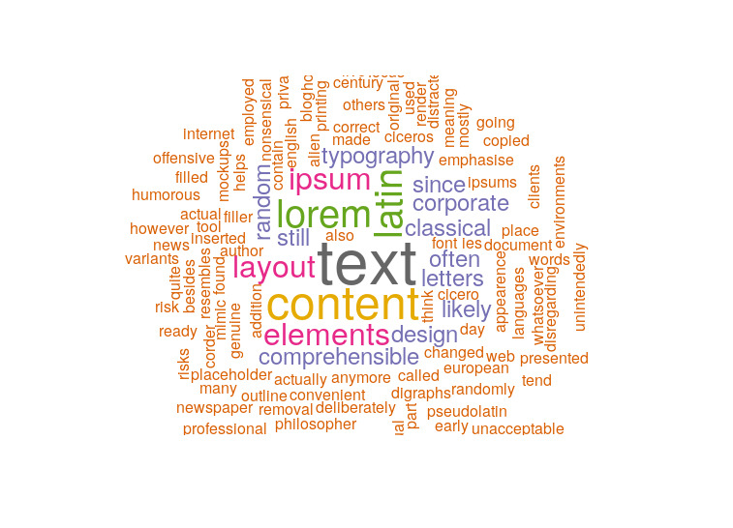

**Q2) Take a time series data. Show the three components of the time series data.**

> library(Quandl)

> Quandl.search("new home construction")

Uruguay - New Housing Construction Index

Code: SGE/URYHOUS

Desc: <p>This index tracks the number of new houses built in Uruguay .</p><p><b>Units: </b>Index Points 1990=100, NSA</p><p><b>Source: </b><a href =http://www.ine.gub.uy/>Instituto Nacional de Estadstica, Uruguay</a></p>

Freq: quarterly

Cols: Date | Value

Housing Market Indicators in New Brunswick: Construction

Code: CMHC/NB_HOUSINGCONSTRUCTION

Desc: These tables bring together information from a variety of sources. They provide an overview of housing conditions and trends in Canada and in each province and Census Metropolitan Area. Some tables assemble data for different markets, while others feature one particular market. Contents include information on housing construction, and sales; rental market trends; mortgage lending; the housing stock; household characteristics; and housing need. Tables also contain data on factors that influence housing markets, such as employment trends, demographic changes, and income growth.

Freq: annual

Cols: Year | Total Starts | Single Starts | Multiple Starts | Semi-Detached | Row | Apartment | Starts Intended Mkt | Owned | Rental | Condo | Other Starts | Completions

New Privately-Owned Housing Units Under Construction: Total

Code: FRED/UNDCONTNSA

Desc: Thousands of Units Not Seasonally Adjusted,

Freq: monthly

Cols: Date | Value

New Privately-Owned Housing Units Under Construction: Total

Code: FRED/UNDCONTSA

Desc: Thousands of Units Seasonally Adjusted,

Freq: monthly

Cols: Date | Value

New Privately-Owned Housing Units Under Construction in the West Census Region

Code: FRED/UNDCONWTSA

Desc: Thousands of Units Seasonally Adjusted,

Freq: monthly

Cols: Date | Value

New Privately-Owned Housing Units Under Construction in the Midwest Census Region

Code: FRED/UNDCONMWTSA

Desc: Thousands of Units Seasonally Adjusted,

Freq: monthly

Cols: Date | Value

New Privately-Owned Housing Units Under Construction in the Northeast Census Region

Code: FRED/UNDCONNETNSA

Desc: Thousands of Units Not Seasonally Adjusted,

Freq: monthly

Cols: Date | Value

New Privately-Owned Housing Units Under Construction: 1-Unit Structures

Code: FRED/UNDCON1UNSA

Desc: Thousands of Units Not Seasonally Adjusted,

Freq: monthly

Cols: Date | Value

New Privately-Owned Housing Units Under Construction in the Midwest Census Region

Code: FRED/UNDCONMWTNSA

Desc: Thousands of Units Not Seasonally Adjusted,

Freq: monthly

Cols: Date | Value

New Privately-Owned Housing Units Under Construction in the West Census Region

Code: FRED/UNDCONWTNSA

Desc: Thousands of Units Not Seasonally Adjusted,

Freq: monthly

Cols: Date | Value

> Quandl.search("Housing Units Completed", source="FRED")

New Privately-Owned Housing Units Completed: Total

Code: FRED/COMPUTSA

Desc: Thousands of Units Seasonally Adjusted Annual Rate,

Freq: monthly

Cols: Date | Value

New Privately-Owned Housing Units Completed: Total

Code: FRED/COMPUTNSA

Desc: Thousands of Units Not Seasonally Adjusted,

Freq: monthly

Cols: Date | Value

New Privately-Owned Housing Units Completed: 1-Unit Structures

Code: FRED/COMPU1USA

Desc: Thousands of Units Seasonally Adjusted Annual Rate,

Freq: monthly

Cols: Date | Value

New Privately-Owned Housing Units Completed: 1-Unit Structures

Code: FRED/COMPU1UNSA

Desc: Thousands of Units Not Seasonally Adjusted,

Freq: monthly

Cols: Date | Value

New Privately-Owned Housing Units Completed: 2-4 Unit Structures

Code: FRED/COMPU24UNSA

Desc: Thousands of Units Not Seasonally Adjusted,

Freq: monthly

Cols: Date | Value

New Privately-Owned Housing Units Completed: 2-4 Unit Structures

Code: FRED/COMPU24USA

Desc: Thousands of Units Seasonally Adjusted Annual Rate,

Freq: monthly

Cols: Date | Value

New Privately-Owned Housing Units Completed: 5-Unit Structures or More

Code: FRED/COMPU5MUNSA

Desc: Thousands of Units Not Seasonally Adjusted,

Freq: monthly

Cols: Date | Value

New Privately-Owned Housing Units Completed: 5-Unit Structures or More

Code: FRED/COMPU5MUSA

Desc: Thousands of Units Seasonally Adjusted Annual Rate,

Freq: monthly

Cols: Date | Value

New Privately-Owned Housing Units Completed in the Northeast Census Region

Code: FRED/COMPUNETNSA

Desc: Thousands of Units Not Seasonally Adjusted,

Freq: monthly

Cols: Date | Value

New Privately-Owned Housing Units Completed in the Midwest Census Region

Code: FRED/COMPUMWTNSA

Desc: Thousands of Units Not Seasonally Adjusted,

Freq: monthly

Cols: Date | Value

> Units = Quandl("FRED/COMPUTSA")

> head(Units)

Date Value

1 2019-02-01 1303

2 2019-01-01 1247

3 2018-12-01 1063

4 2018-11-01 1101

5 2018-10-01 1111

6 2018-09-01 1148

> value.ts = ts(Value, data=Units, frequency=12, start=c(2000,1), end=c(2018,12))

> plot(value.ts)

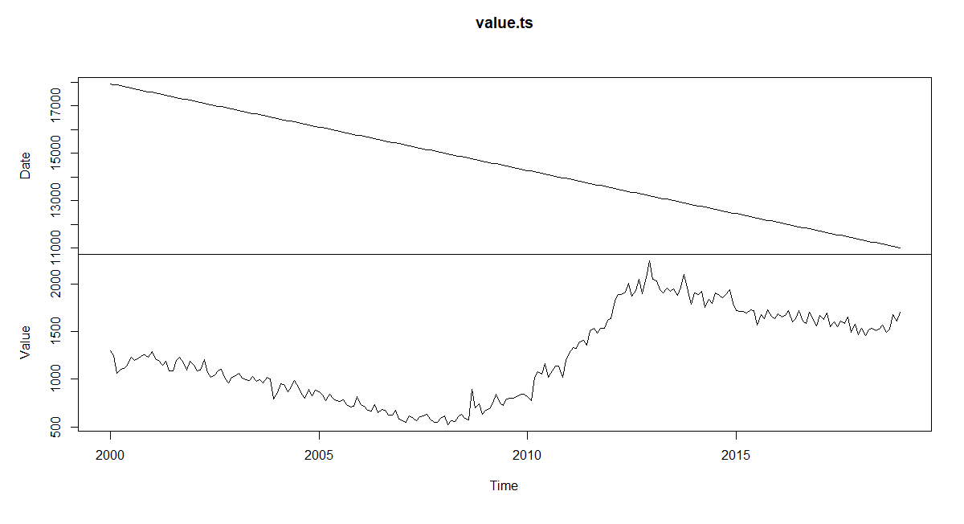

> d = decompose(value.ts)

> plot(d)

